Instructional Materials for GoCanvas Daily COVID-19 Screening
North Country HealthCare

Creating Your Password
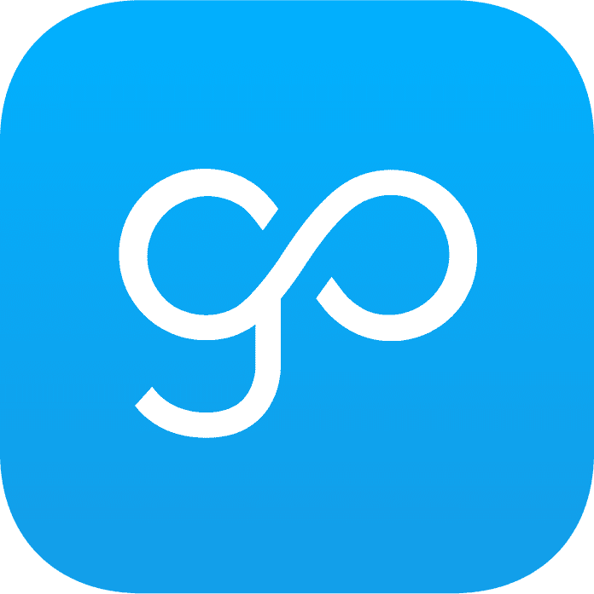
You will be receiving an email from GoCanvas prompting you to set up a password. Once the password has been set up you will receive instructions on how to download the application from the app store. An image of what the GoCanvas app tile looks like is shown here (right), and a screenshot of the email you can expect to receive is shown below.
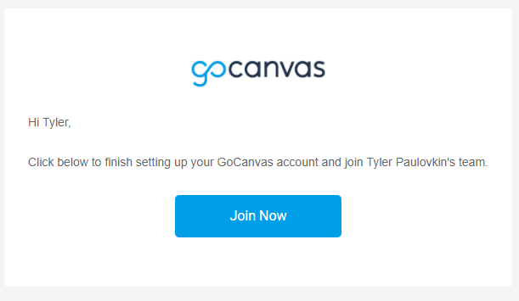

If you did not receive the activation email, follow these steps:
Apple iOS: https://apps.apple.com/us/app/gocanvas-business-forms/id418917158
Android/Google Store: https://play.google.com/store/apps/details?id=com.gocanvas&hl=en_US

Please be aware that for security reasons, you should be using a password that is DIFFERENT from you North Country password.

Device Compatibility
If you do not have one of compatible devices below, you can access your GoCanvas account and complete screenings by installing the desktop app on your PERSONAL computer. To access GoCanvas without a compatible device, visit https://www.gocanvas.com/m, select “Log In”, and you will be taken to the landing page.

iPhone/iPad: iOS 12 and higher
Android Smartphones/Tablets: Android 8.0 and higher
Windows Desktop/Tablet Devices: Windows 8 and higher

Settings and Notifications

App Permissions
Once you log into GoCanvas with your email and password, you may be prompted by the app to allow or deny certain permissions, such as for GoCanvas to access photos, contacts, or storage. While it is up to you whether or not you allow or deny these permissions, there is an important functionality associated with the storage permission. You can manage your app permissions after install by going to your device settings.

Access to Storage:
Allowing GoCanvas to have access to storage will allow you to save your responses to submission that is in progress and be able to return to it later or if you are interrupted.
Denying this permission simply means any unsaved submissions will be lost, and you will have to start from the beginning with a new submission.

Notifications
GoCanvas will send out a push notification every morning at 7:00 AM seven days a week. These notifications are simply reminders to complete the screening, and therefore are not interactive. Occasionally, there may be small changes or updates that need to occur for which you will also get a notification. Please know that you do not need to wait for the reminder notification in order to complete the daily screening, and you can simply open the app to screen at any time BEFORE you arrive for work.

Please do not disable notifications from GoCanvas on your individual device! They are there to help and remind you and to keep our employees and patients safe!

Going Through the Daily Screening

All employees are required to self-screen (including taking and recording your temperature) in the app every morning. These are screenshots from the app on an iPhone 8S, so your screen may look slightly different based on the device you have.

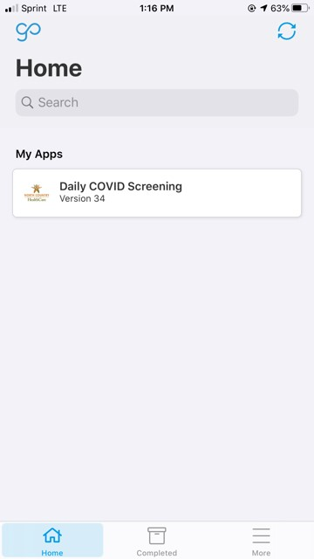

Main Landing Page
Once you log into the GoCanvas app, you will be brought to this landing page. For the time being, you will only have one “App” listed.

Click “Daily COVID Screening” to be taken to the screening questions.

Other Tabs
More information and screenshots of the “Completed” and “More” tabs are at the end of this document (page 7).
Screening Questions
Once you click on the screening, the first page will show some default, read-only information. You will not be able to change your name, department, location, or date on this page. (If you work from multiple locations there is a question to address that.)

Select whether you are coming in, working from home (WFH), or not working.

Take you temperature using a digital thermometer and enter the precise value into the temperature field.

Answer the rest of the screening questions, check the box that you have answered truthfully, and hit “Next”.
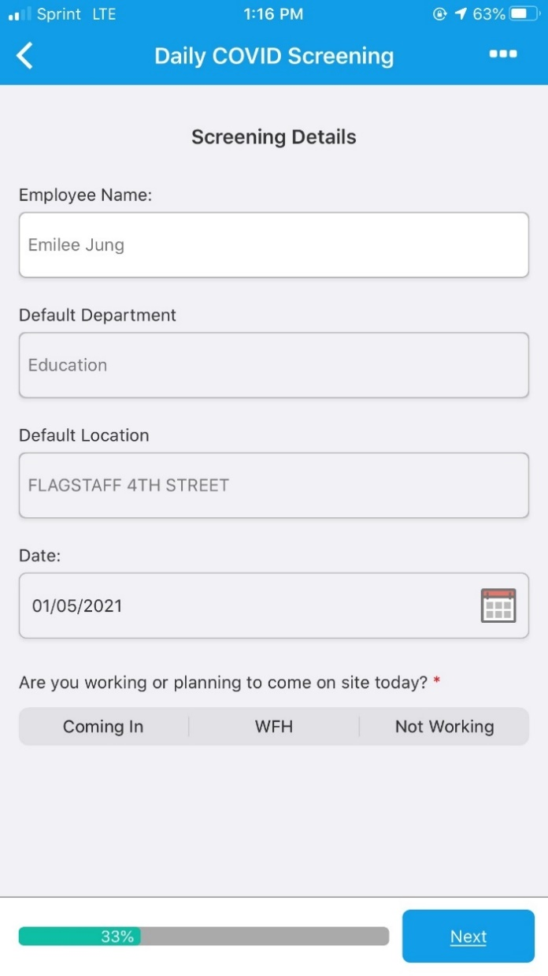
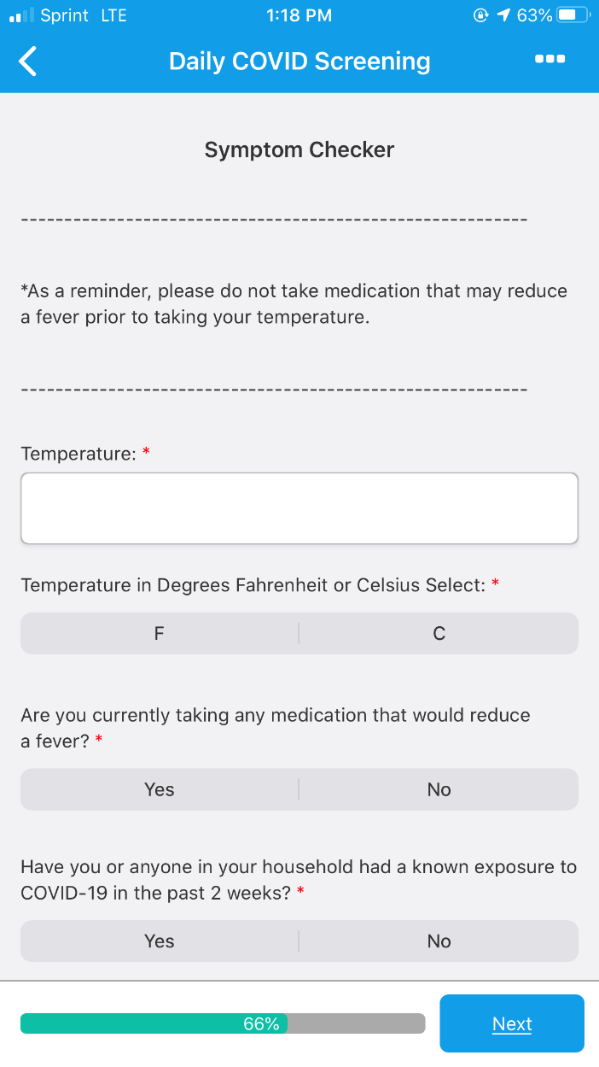
Review Page
After you have finished answering all the questions and hit “Next”, you will be taken to a page where you can review your responses before submitting. In addition, there are a few settings on this page that require explanation.

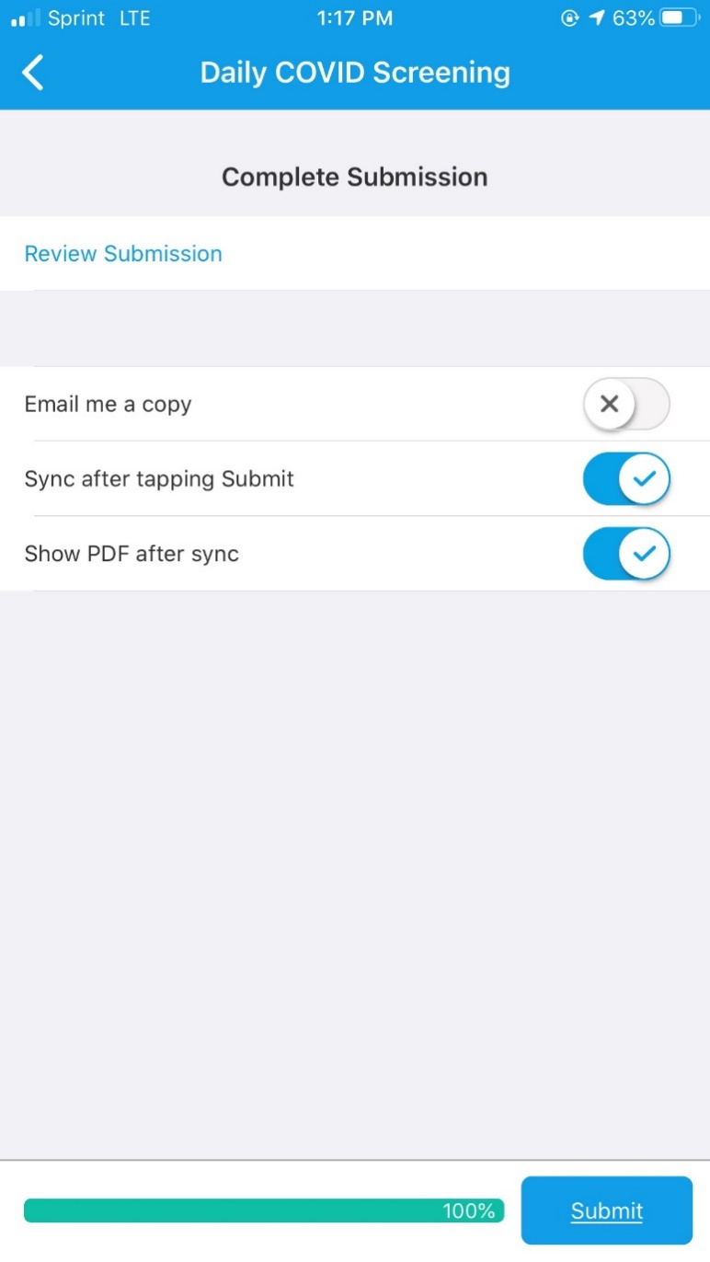

“Email me a copy”: It is entirely up to you whether you’d like an email copy of your submission. The message will go directly to your North Country email and will contain your results PDF.

“Sync after tapping Submit”: KEEP ON! This will sync the app for any changes or updates so that you do not need to do so manually.

“Show PDF after sync”: YOU MUST KEEP THIS ON! The PDF will act as your screening result and clearance into the workspace. Unselecting this will return you to the main landing page upon submit, and it will not give your screening result.

These settings will automatically default to what you selected during your previous submission. So, by turning them ON the first time, you will not need to remember to do it every time.

Results PDF
Once you click “Submit”, you will be shown a PDF of the results from your daily screening. Depending on your temperature and how you responded to the screening questions, you will get one of the two screens below.

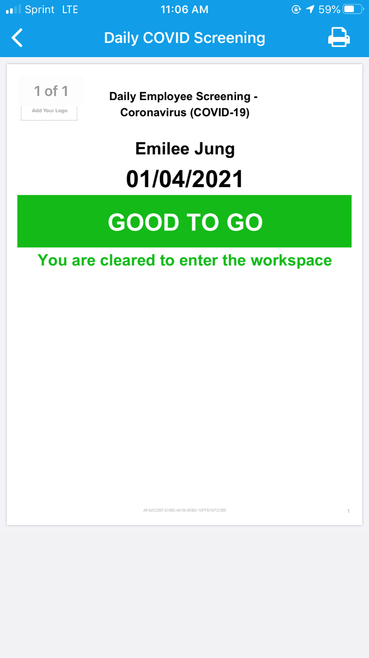
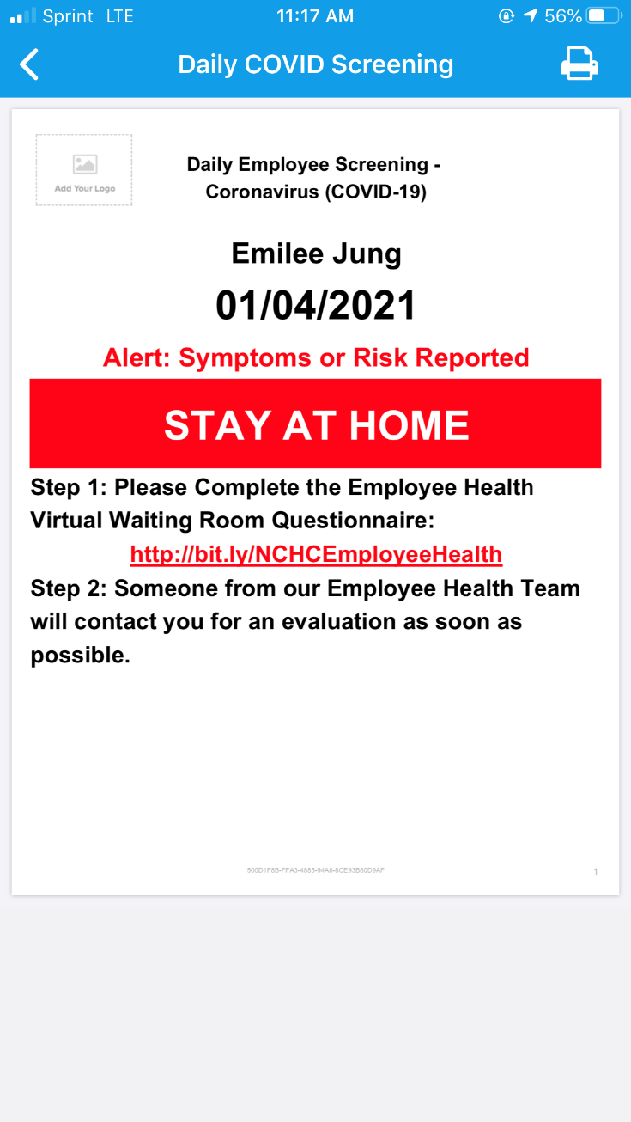
If your result is “STAY AT HOME”: You MAY NOT enter the building to come to work. Follow the steps listed in the PDF and complete the Employee Health Virtual Waiting Room. The link to the waiting room is embedded into the PDF, and you should be able to click it and be taken right to the Smartsheet form.

If your result is “GOOD TO GO”: You are cleared to enter the facility to work. You may also be required to show your supervisor or an employee screener this PDF upon arrival.

More Tabs and Options
Until self-screening with GoCanvas has fully launched, you will be required to show the screeners your PDF upon arrival. You can use the “Completed” tab to access each of your past PDF results. Clicking any of these will pull up the PDF and either the “GOOD TO GO” or “STAY AT HOME” banner.

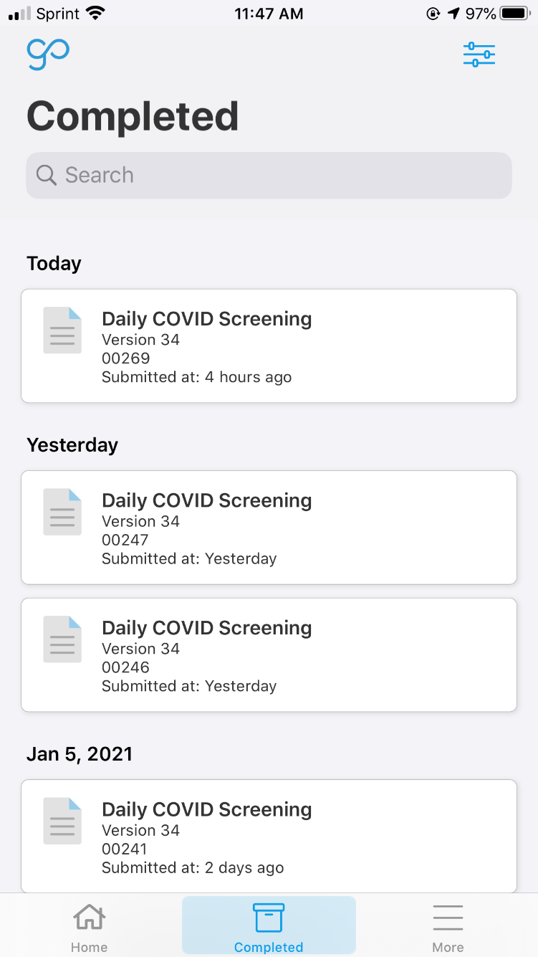
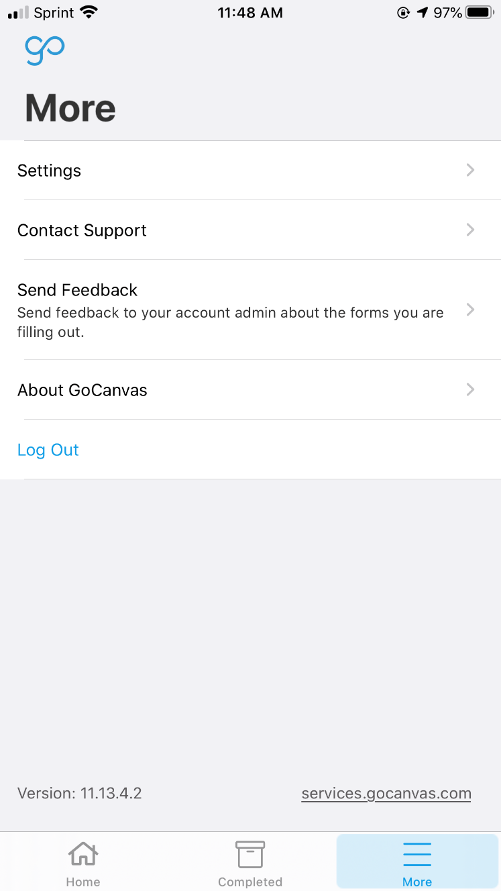
Under the “More” tab, you can manage settings and permissions after install, and it is also where you can find the “Log Out” button.

